Pages :
- Login page
- Account Creation Page
- Profile Creation Page
- Profile View Page
- Dashboard Page
- Record entry Page
- Stats Page

Folder structure :
- Project
  - Static
    - CSS
      - Dailyrecord.css
      - Login.css
      - Profile.css
    - Createaccount.js
    - Dailyrecord.js
    - Dashboard.js
    - Graph.js
    - Login.js
    - Profile.js
    - Profilefreeze.js
  - Templates
    - Createaccount.html
    - Dailyrecord.html
    - Dashboard.html
    - Graph.html
    - Profile.html
    - Profilefreeze.html
  - Init.py
  - Function.py
  - Health_tracker.sql
  - Requirements.txt

Software’s Used :
- Python (2.6)
- Flask(Python Frame work)
- HTML
- CSS
- Java script (JS)
- My SQL database
- Xampp software

Pip Packages Used and Versions:
- click==7.1.1
- Flask==1.1.2
- Flask-Cors==3.0.8
- itsdangerous==1.1.0
- Jinja2==2.11.1
- MarkupSafe==1.1.1
- mysql-connector==2.2.9
- six==1.14.0
- Werkzeug==1.0.1

Data Base Name : health_tracker
Tables in Data base:
1.user
S.no | Name | Data Type | Allow Null | Default | Keys
1 | UserId | Int | Yes | Null | Primary Key(Auto increment )
2 | UserEmail | Varchar(100) | Yes | Null
3 | UserPassword | Varchar(50) | Yes | Null
4 | IsActive | Tinyint | Yes | Null
5 | DateCreated | Datetime | Yes | Null
6 | DateModified | Datetime | Yes | Null
7 | IsProfileCreated | tinyint | No | 0

2.personalprofile
S.no | Name | Data Type | Allow Null | Default | Keys
1 | ProfileId | Int | Yes | Null | Primary Key(Auto increment )
2 | UserId | Int | Yes | Null | Foreign Key
3 | MiddleName | Varchar(50) | Yes | Null
4 | LastName | Varchar(50) | Yes | Null
5 | DateOfBirth | Varchar(50) | Yes | Null
6 | Height | Date | Yes | Null
7 | Weight | Float | Yes | Null
8 | Sex | Float | Yes | Null
9 | Age | Varchar(10) | Yes | Null
10 | BMIValue | Int | Yes | Null
11 | BMICategory | Float | Yes | Null
12 | Address | Varchar(50) | Yes | Null
13 | PhoneNumber | Varchar(100) | Yes | Null
14 | MinWeight | Varchar(50) | Yes | Null
15 | MaxWeight | Float | Yes | Null
16 | BMRValue | Float | Yes | Null
17 | SuggestedBMRValue | Float | Yes | Null
18 | Message | Varchar(100) | Yes | Null
19 | IsActive | Tinyint | No | 0
20

3.DashBoard
S.no | Name | Data Type | Allow Null | Default | Keys
1 | DashBoardId | Int | Yes | Null | Primary Key(Auto increment )
2 | UserId | Int | Yes | Null | Foreign Key
3 | IdealBMRValue | Float | Yes | Null
4 | Calorielnput | Float | Yes | Null
5 | CalorieOutput | Float | Yes | Null
6 | FinalCalorie | Float | Yes | Null
7 | Variation | Float | Yes | Null
8 | Date | Date | Yes | Null
9 | IsActive | Tinyint | No | 0
10 | DateCreated | Date time | Yes | Null

Reference:
- https://canvasjs.com/docs/charts/how-to/render-multiple-charts-in-a-page/
- https://canvasjs.com/jquery-charts/column-chart/
- https://www.calories.info/food/fruit-juices
- https://www.calculator.net/calorie-calculator.html
- https://www.health.harvard.edu/diet-and-weight-loss/calories-burned-in-30-minutes-of-leisure-and-routine-activities
- https://colorlib.com/wp/template/creative-login-form/
- https://colorlib.com/wp/template/colorlib-contact-form/
- https://www.w3schools.com/

Code flow

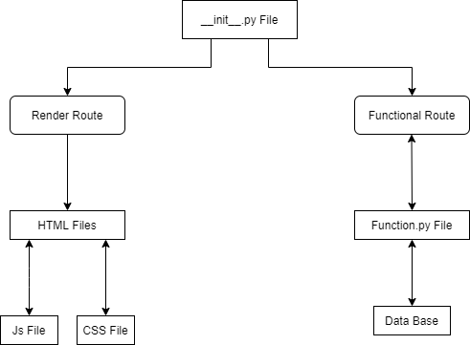

Application flow
